Web Development – Mr. Turner

Project – Spiderman Puzzle

**Project Overview**

Everyone likes doing a puzzle. Your page will allow users to mix up the pieces of a spiderman puzzle and then click them back into place.

**The Page**

The interface for the page will be as follows. When the page loads, the pieces will appear in their proper order.

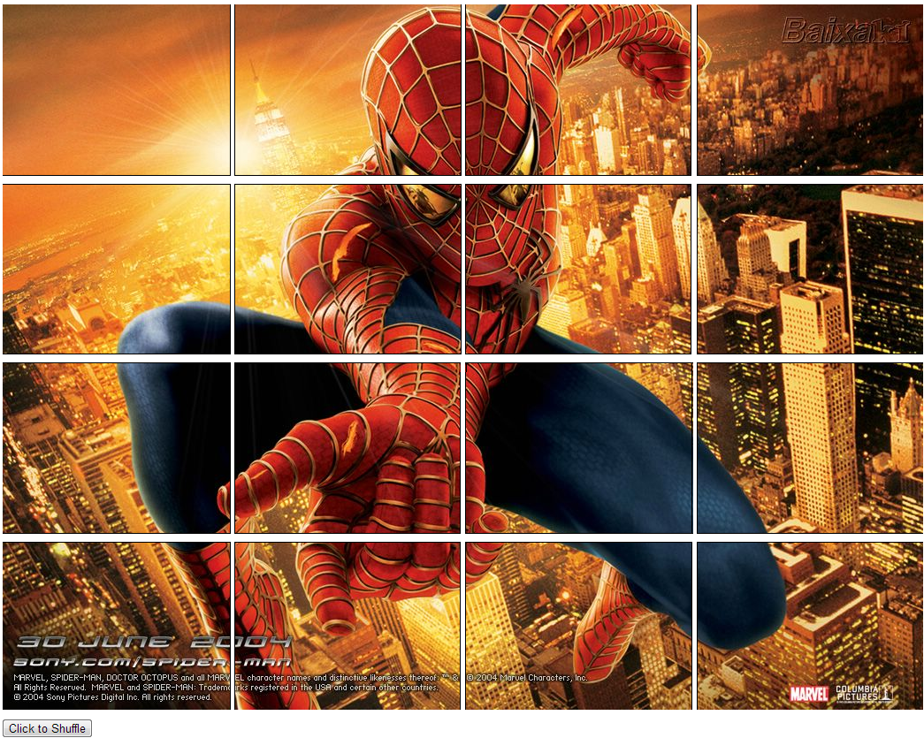

The user will then shuffle the pieces by clicking the button.

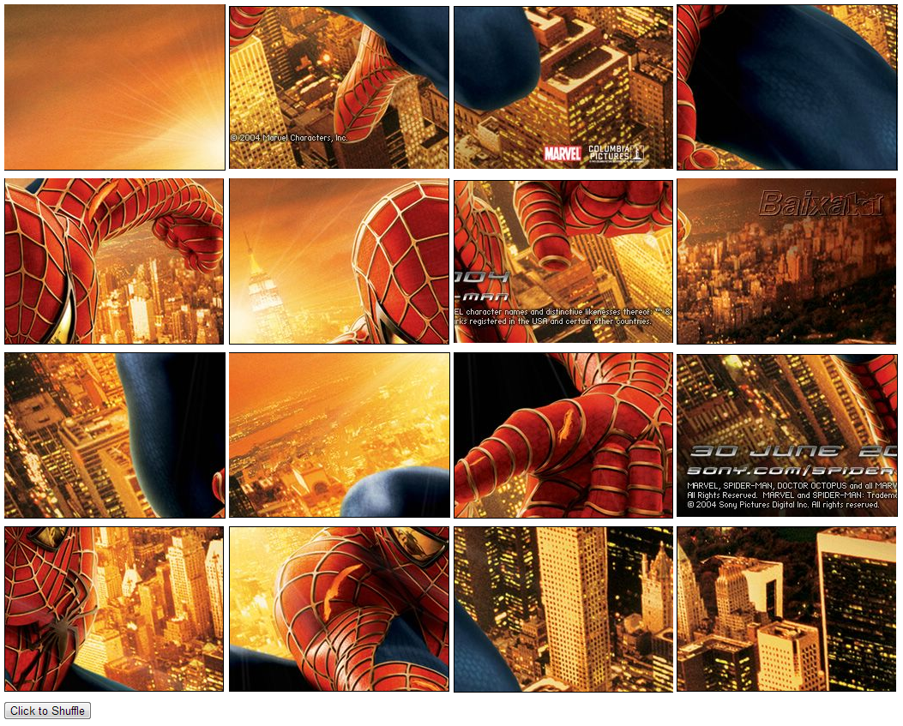

Switching tiles is a 2-click process. When the client clicks on one of the tiles, it will be highlighted in green.

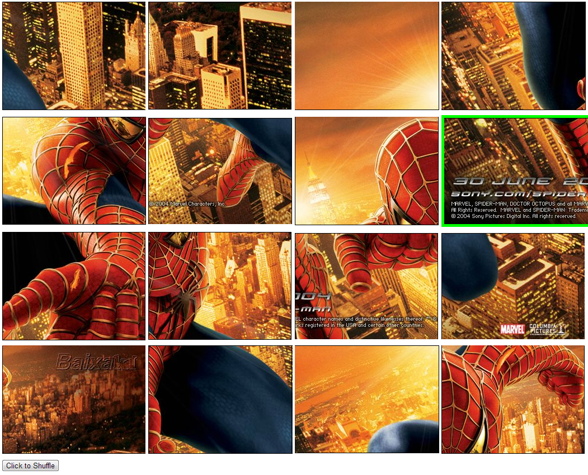

When the user clicks on a second tile, it will switch with the first one.

When the puzzle is complete, the program post a message congratulating the user.

Organize the puzzle into a table so that the layout is easy to manipulate. Use CSS to decorate your page, giving it the look and feel you want.

**Bonus**

When the puzzle is complete, show the original image itself.

Create a “splash” page, which gives the user a selection of puzzles. Each selection will link to a different page which has a different puzzle.

**Programming Requirements**

|  |
| --- |
| * You must code your own HTML and CSS. Use of a drag and drop interface or the usage of code downloaded from the internet is not permitted. |
| * Use of deprecated code is not permitted. Use an HTML 5 reference as your guide. |
| * You must comment your name into the top of every page. |
| * Your code must be structured in a consistent and legible manner |
| * Your text must be organized through the use of sectioning tags (div, span, p, h1 – h6). Tables are acceptable for data but not for page design. |
| * Your interface must be smooth and easy to figure out for a client. |
| * Your pages must be formatted using CSS. |

*You project is to be submitted via Moodle. Compress all of the necessary files into a zip file.*